**Problem Statement**

Create a calculator to work with rational numbers.

Requirements:

•It should provide capability to add, subtract, divide and multiply rational numbers

•Create a method to compute GCD (this will come in handy during operations on rational)

•Add option to work with whole numbers which are also rational numbers i.e. (n/1)

-achieve the above using auxiliary constructors

-enable method overloading to enable each function to work with numbers and rational.

**Solution-**

**class**Calc (n:Int, d:Int){

*require*(d!=0)

**private val***g*= gcd(n.abs,d.abs)

**val***numerator*= n/*g*

**val***denominator*= d/*g*

**private def**gcd(x:Int, y:Int) :Int = {

**if**(x==0) y

**else if**(x<0) gcd(-x,y)

**else if**(y<0) gcd(x,-y)

**else**gcd(y%x,x)

}

**def this**(n: Int) = **this**(n, 1) ***// auxiliary constructor***

|  |  |  |  |
| --- | --- | --- | --- |
| **def**add | (r:Calc): Calc | = |  |
| **new**Calc(*numerator*\* | | r.*denominator*+ r.*numerator*\**denominator*, | |
| *denominator*\*r.*denominator*) | |  |  |
| **def**add | (i: Int): Calc | = | ***// overloaded for add*** |
| **new**Calc(*numerator*+ | | i * *denominator*, *denominator*) | |

**def**subtract (r:Calc) =

**new**Calc(*numerator*\*r.*denominator*- r.*numerator*\**denominator*,*denominator*\*r.*denominator*)

|  |  |  |
| --- | --- | --- |
| **def**subtract (i: Int): | Calc = | ***// overloaded for subtract*** |
| **new**Calc(*numerator*- | i * *denominator*, *denominator*) | |

**def**multiply (r:Calc) =

**new**Calc(*numerator*\*r.*numerator*,*denominator*\*r.*denominator*)

|  |  |  |
| --- | --- | --- |
| **def**multiply (i: Int): | Calc = | ***// overloaded for multiply*** |
| **new**Calc(*numerator*\* | i , *denominator*) | |

**def**divide (r:Calc) =

**new**Calc(*numerator*\*r.*denominator*,*denominator*\*r.*numerator*)

**def**divide (i: Int): Calc = ***// overloaded for division***

**new**Calc(*numerator*, *denominator*\* i)

**override def**toString = *numerator*+ **"/"**+ *denominator*

}

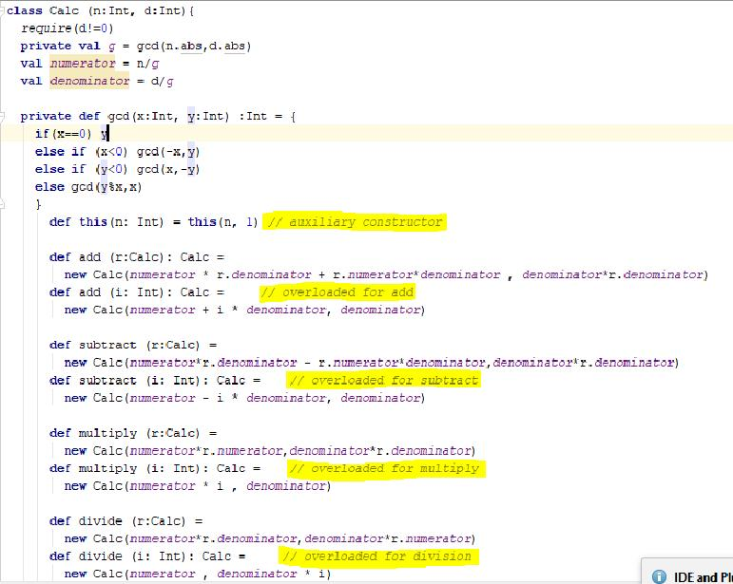

**object**CalcObj {

**def**main(args: Array[String]): Unit = {

**val**a = **new**Calc(10,9) **val**b = **new**Calc(17) **val**c = **new**Calc(13,26) **val**d = **new**Calc(11) **val**p = a add 5 *println*(p)

**val**q = b multiply **new**Calc(11,9) *println*(q)

**val**r = c subtract **new**Calc(16,1) *println*(r)

**val**s = d divide 51 *println*(s)

}

}

-

